Get Career Savvy (GCS)

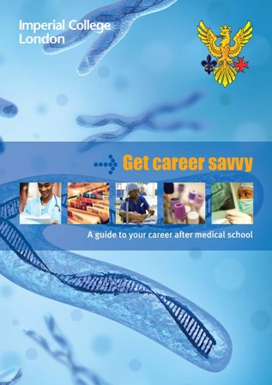
After months of hard work, the Faculty of Medicine and Imperial College School of Medicine Student's Union is proud to launch 'Get Career Savvy' (GCS). GCS is our new careers booklet aimed at medical students across all years. You'll hopefully find it an aid in helping you gain a taster on what life after graduation entails.

The booklet contains entries from all different specialities: from Vascular Surgery to Paediatrics. Here you can find out what the speciality entails, the career pathway and what exams you might be expected to complete. Furthermore, each page has an interview from a trainee or Consultant. At the back of GCS you'll find a list of contacts, so you can personally email people in the field for further advice.

This book should be used as a guide and a guide only. We've tried to cover all aspects of careers advice from Foundation Training to volunteering abroad. The guide will be made available in due course on the ICSM intranet in PDF version too.

GCS would like to thank everyone who has been involved, from the editorial team to all those interviewed to make this guide possible.

Editorial Team GCS

